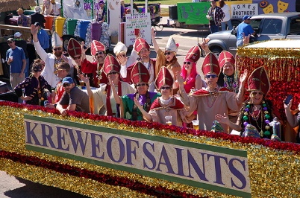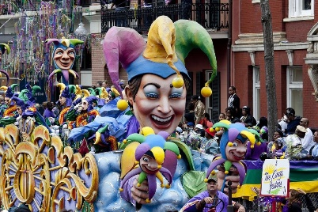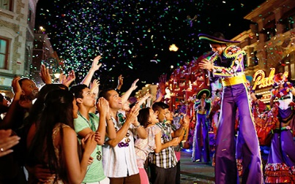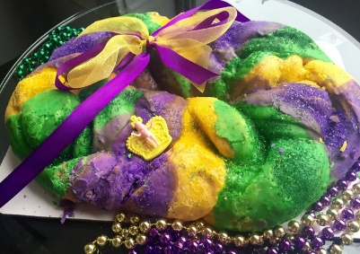

**Grab your costume and join the Mardi Gras party.**

**Experience Mardi Gras like New Orleans**

**Have you tried King Cake**?



**Don your masks and costumes for the Mardi Gras parties.**

**The Krewe of Bacchus parade will not disappoint as it rolls.**

**The Krewe rolls through the carnival to celebrate Mardi Gras.**